姓名： _____月_____ 日 星期_____
中文___ ____年级

about “辶”

Task (A) What is the component shared by all of the characters below?

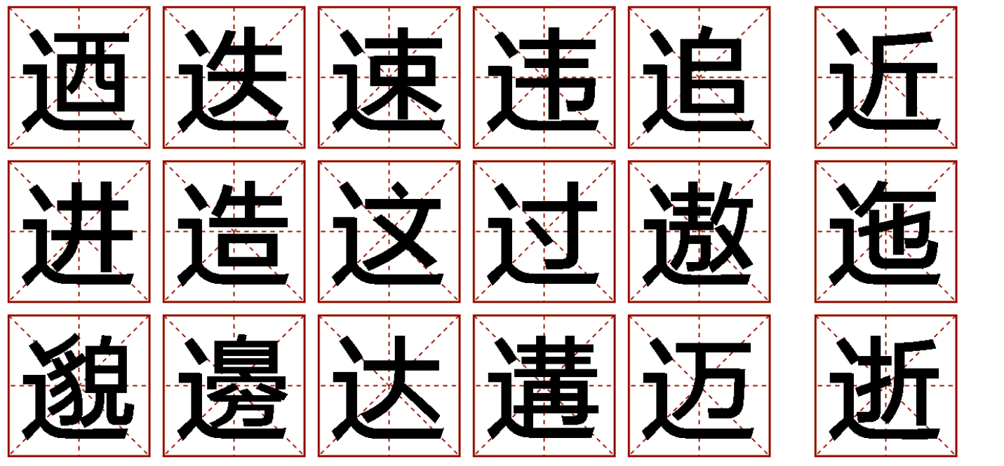

Task (B)
- With your partner, scan text1 and highlight every character which has this radical.
Remember: it must be on the left!
- Choose 1 of the characters discuss with your partner what you “think” is the correct way to write this character, practice writing in the boxes below:
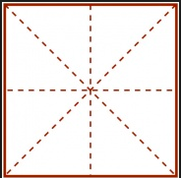
- After you think you have written the character correctly, go to mdbg.net and draw the character into the dictionary. Check stroke order and direction (did you guess correctly?)

- Re-write one more time, following the correct stroke order and direction
- Write the pinyin for the character_________________

